Conduit Test plan

**Introduction** **2**

**1. Test strategy** **2**

1.1 Scope of testing 2

1.1.1 Feature to be tested 2

1.1.2 Feature not to be tested 4

1.2 Test type 5

1.3 Risk and issues 5

1.4 Test logistics 5

1.4.1 Who will test? 5

1.4.2 When will the test occur? 5

**2. Test objective** **6**

**3. Test criteria** **6**

3.1 Suspension criteria 6

3. 2 Exit criteria 6

**4. Resource planning** **6**

4.1 System resource 6

4.2 Human resource 7

**5. Test environment** **7**

**6. Schedule & estimation** **8**

6.1 All project tasks and estimation 8

6.2 Schedule to complete these tasks 8

**7. Test deliverables** **9**

7.1 Before testing phase 9

7.2 During the testing 9

7.3 After the testing cycle is over 9

# 

# Introduction

The “Conduit” app is designed as an open source to train software development and testing

skills. The website's main functionality includes registration and sign-in, posting articles on different topics, reading articles, liking an article, posting a comment, and following a user.

The Test Plan is designed to prescribe the scope, approach, resources, and schedule of all

testing activities of the “Conduit” website.

The plan identifies the features to be tested, the testing types, the resources

and schedule required to complete testing, and the risks associated with the plan.

# 1. Test strategy

## 1.1 Scope of testing

### 1.1.1 Feature to be tested

| Module name | Login type | Description |
| --- | --- | --- |
| Header | User Logged-in | There should be a logo + 3 links: “New article”, “Settings” and “User’s page” |
| User Logged-out | There should be a logo + 3 links: “Sign in”, “Sign up” and “Home” |
| Sign-up | User Logged-out | User can click on the “Sign up” link in the header. The link redirects the user to the new page with 3 text fields (“Username”, “Email”, and “Password”) to fill in. All the fields are mandatory. After filling in all the fields, the user can click on the [Sign up] button. |
| Sign-in | User Logged-out | Users can click on the “Sign in” link in the header. The link redirects the user to the new page with 2 text fields (“Email”, and “Password”) to fill in. All the fields are mandatory. After filling in all the fields, the user can click on the [Sign in] button. |
| Global Feed | User Logged-in /  User Logged-out | In this tab users can see the last published articles. One page contains 10 articles. |
| Your Feed | User Logged-in | In this tab, users can see the latest articles published by the users they subscribe to. There are 10 articles on one page. |
| Popular tags | User Logged-in /  User Logged-out | In this section users can see the tags that are most often found in articles. By clicking on the tag users should be able to see articles with such tag. The section is visible for both Global Feed (and Your Feed(if logged in)) |
| New Article | User Logged-in | On this page users are able to publish a new article by filling in all the mandatory fields. Mandatory fields are “Title”, “What's this article about?” and “Write your article” |
| Article | User Logged-in | Users can access the article page from the Global/Your feed tab. On this page, user can like article, follow article's author, and write a comment. |
| User Logged-out | Users can access the article page from the Global Feed tab. On this page, users can read more details about the article. |
| Users page | User Logged-in | On this page users can see their last published articles in “My posts” and their last favourite articles in “Favourite articles” |
| Another user’s page | User Logged-in | On this page users can view articles written by another user and user’s favourite article, like articles and follow this user. |
| User Logged-out | On this page users can view articles written by another user and the user’s favourite article. |
| Settings | User Logged-in | On this page users are able to add/change their profile picture, change their username, and write a short bio. Change the username and reset password functions are also should be on this page. After making changes users should be able to save them by clicking on the [Update Settings] button. By clicking on the [Logout] button users should be able to log out from the site. |
| Footer | User Logged-in /  User Logged-out | There should be a logo + “Thinkster” link |

### 

### 1.1.2 Feature not to be tested

These features are not be tested because they are not included in the software requirement specs:

* Compatibility
* Accessibility
* Software Interfaces
* Database logical
* Website Security and Performance

## 1.2 Test type

In the Conduit app, there’re 3 types of testing should be conducted.

* **User Acceptance** (customers of the system compare the system to its initial requirements.)
* **Failover and Recovery** (validates the product under test for its ability to recover successfully from potential failures due to software bugs, hardware failures, or communication problems (such as network failure).
* **Localization** (checks that site offers full functionality and usability in a particular locale)

## 1.3 Risk and issues

| Risk | Mitigation |
| --- | --- |
| **Power outages, rolling blackouts** | All devices are connected to uninterruptible power supplies to prevent data loss |
| **Lack of a stable internet connection** | Set up an alternative source of Internet connection |
| **Testing team has low experience in the Failover/Recovery testing** | Plan training course to skill up your members |
| **Lack staff in the team can increase the time of the testing process** | Hire an employee for the testing team |
| **The absence of a German-speaking employee can make the localization check process difficult** | Hire a German-speaking employee / Teach one of the workers German |

## 1.4 Test logistics

### 1.4.1 Who will test?

Testing will be done by the **qa_sep22** team.

### 1.4.2 When will the test occur?

QA team will start the test execution when all the following inputs are ready:

* All product requirements are reviewed.
* Latest build of the product is made.
* Test environment is set up.
* Test data is ready.
* Enough human resources for testing.

# 2. Test objective

The test objectives are to verify the functionality of the Conduit app. The testing should be focused on the flow of publishing articles and sharing information between members. The main features are authorization, posting new articles, following members, saving favorite articles on their own pages, adding likes, and writing comments. Testing should be done on the latest version (106.0.5249.91) of Google Chrome browser

# 3. Test criteria

### 3.1 Suspension criteria

* If the team members report that there are 30% of test cases failed.
* If there is at least 1 bug with “Critical” Priority

### 3. 2 Exit criteria

* Test execution rate is 100%.
* Test pass rate is at least 95%
* All cases with “Critical” priority are passed (**this point is mandatory**)

# 4. Resource planning

## 4.1 System resource

| No. | Resources | Description |
| --- | --- | --- |
| 1. | Server | Apache web server was chosen to host the site. |
| 2. | DB Server | Need a server (with MySql) to store and manage databases that are stored on the server and to provide data access for authorized users. |
| 3. | VCS | Create local and remote repositories for tracking changes in application versions |
| 4. | Bug-tracking system | Jira was chosen as a bug-tracking system (keeps track of bugs (and suggestions) for the project) |
| 5. | Docker | To run the app locally for working with DB |
| 6. | Computer | At least 4 computers run Windows 10, RAM 8GB, CPU 3.4GHZ |

## 4.2 Human resource

| No. | Member | Tasks |
| --- | --- | --- |
| 1. | Test Manager | * Manage the whole project * Provide management reporting |
| 2. | Test Designer | * Identifies prioritizes and implements test cases. * Generate test plan |
| 3. | Tester | * Execute tests * Reporting bugs * Test documentation review |
| 4. | Test system administrator | * Setting up testing environment * Preparing required test data |
| 5. | Qa Engineer | * Product quality check * Check to confirm whether the testing process is meeting specified requirements |

# 5. Test environment

Testing should be conducted in the production environment.

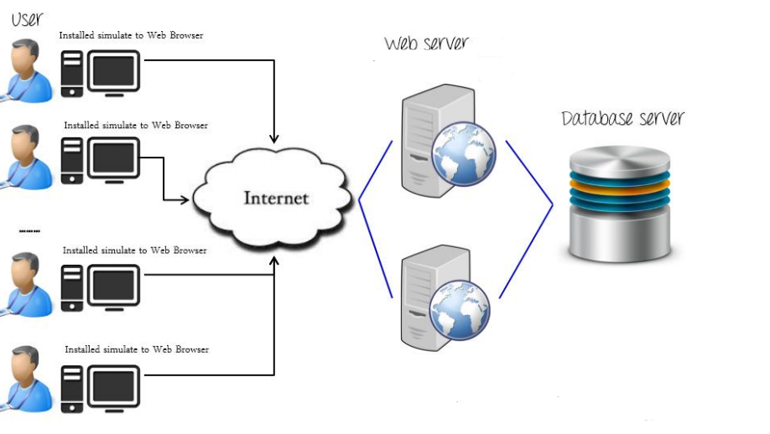

# 6. Schedule & estimation

## 6.1 All project tasks and estimation

| Task | Members | Estimate effort |
| --- | --- | --- |
| Site decomposition | Tester | 2 man - hour |
| Test case development | Test Designer | 38 man - hour |
| Setting up testing environment | Test system administrator | 4 man-hour |
| Prepare required test data | Test system administrator | 4 man - hour |
| Tests execution | Tester/Test system administrator | 16 man - hour |
| Reporting bugs | Tester | 4 man - hour |
| Test report | Test Manager | 12 man - hour |

## 6.2 Schedule to complete these tasks

| Task | Start date | End date |
| --- | --- | --- |
| Site decomposition | 24/10/2022 | 24/10/2022 |
| Test case development | 24/10/2022 | 28/10/2022 |
| Setting up testing environment | 31/10/2022 | 31/10/2022 |
| Prepare required test data | 31/10/2022 | 31/10/2022 |
| Tests execution | 01/11/2022 | 03/11/2022 |
| Reporting bugs | 03/11/2022 | 03/11/2022 |
| Test report | 03/11/2022 | 04/11/2022 |

## 

# 7. Test deliverables

## 7.1 Before testing phase

* Requirements
* Test design specification
* Test cases
* Decomposition
* Empty RTM

## 7.2 During the testing

* Test data
* Test tools
* Error logs
* RTM with data

## 7.3 After the testing cycle is over

* Bug reports
* Test report